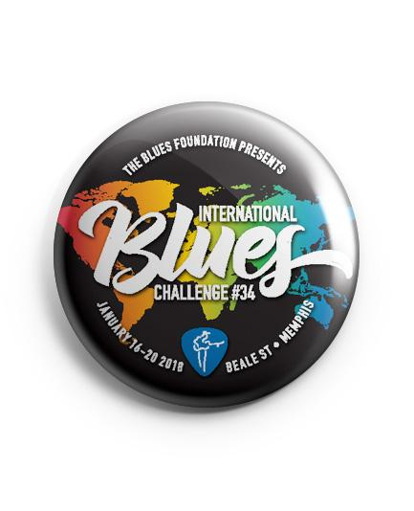

Road to Memphis Competition Rules and Regulations

1. At least one member of each act entering the competition MUST be a Grand River Blues Society member.
2. All winning participants in the 'Road to Memphis' Competition must hold a valid Canadian passport (with more than 6 months to expiration).
3. All winning participants must be able to enter the United States of America to compete.
4. All entries must not have competed in another IBC contest for Jan 2019.
5. Winning Solo/Duo and Band acts must represent the Grand River Blues Society at the International Blues Challenge in the same configuration that won the competition. • substitution of any member must have a valid reason (for example – a medical problem that stops you from attending) and must be approved by the IBC Committee.
6. All artists that are competing must be available to go to Memphis, Tennessee from Tuesday, January 22, 2019 to Saturday, January 26, 2019 inclusive.
7. Winners will be expected to stay in Memphis for the duration of the competition, arriving on Tuesday of Competition week and departing on Sunday. • exceptions must be presented before travel to the IBC Committee.
8. All winning performers must be able to participate in GRBS Road to Memphis Fund Raiser to be held Saturday November 24th at The Rhapsody Barrel Bar Kitchener.
9. In the event any of the governing Local Rules and Bylaws or Competition Rules found at blues.org are violated, the second place Solo/Duo or Band will be promoted and sent to represent the Grand River Blues Society in Memphis.
10. Deadline for receiving entries is Monday, September 24, 2018.

