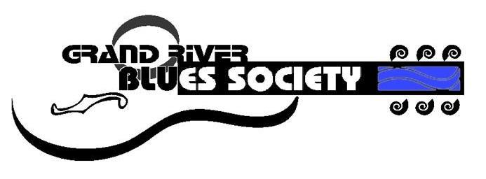
Grand River Blues Society
Annual General Meeting 2018
FEEDBACK AND COMMENTS

- What does ‘the blues’ mean to you?

- What do you like most about our society?

- What would you like to see more of?

- Circle and note your specialized skills, knowledge, competencies, and experience in the following areas:
  - Socializing with people ____________________________________
  - Attending blues events_____________________________________
  - Listening to music_________________________________________
  - Learning and education____________________________________
  - Will travel_______________________________________________
  - Advertising & Marketing___________________________________
  - Newsletters_____________________________________________
  - Website________________________________________________
  - Event volunteer__________________________________________
  - Fundraising_____________________________________________
Did you know you could be the next, most needed volunteer and/or director? Add your name and contact info here: ___________________
____________________________________________________________
- Other Comments: ____________________________________________
____________________________________________________________
Use other side for additional comments (p.s. if you have that much to say.. please complete question #4)

